AGENDA
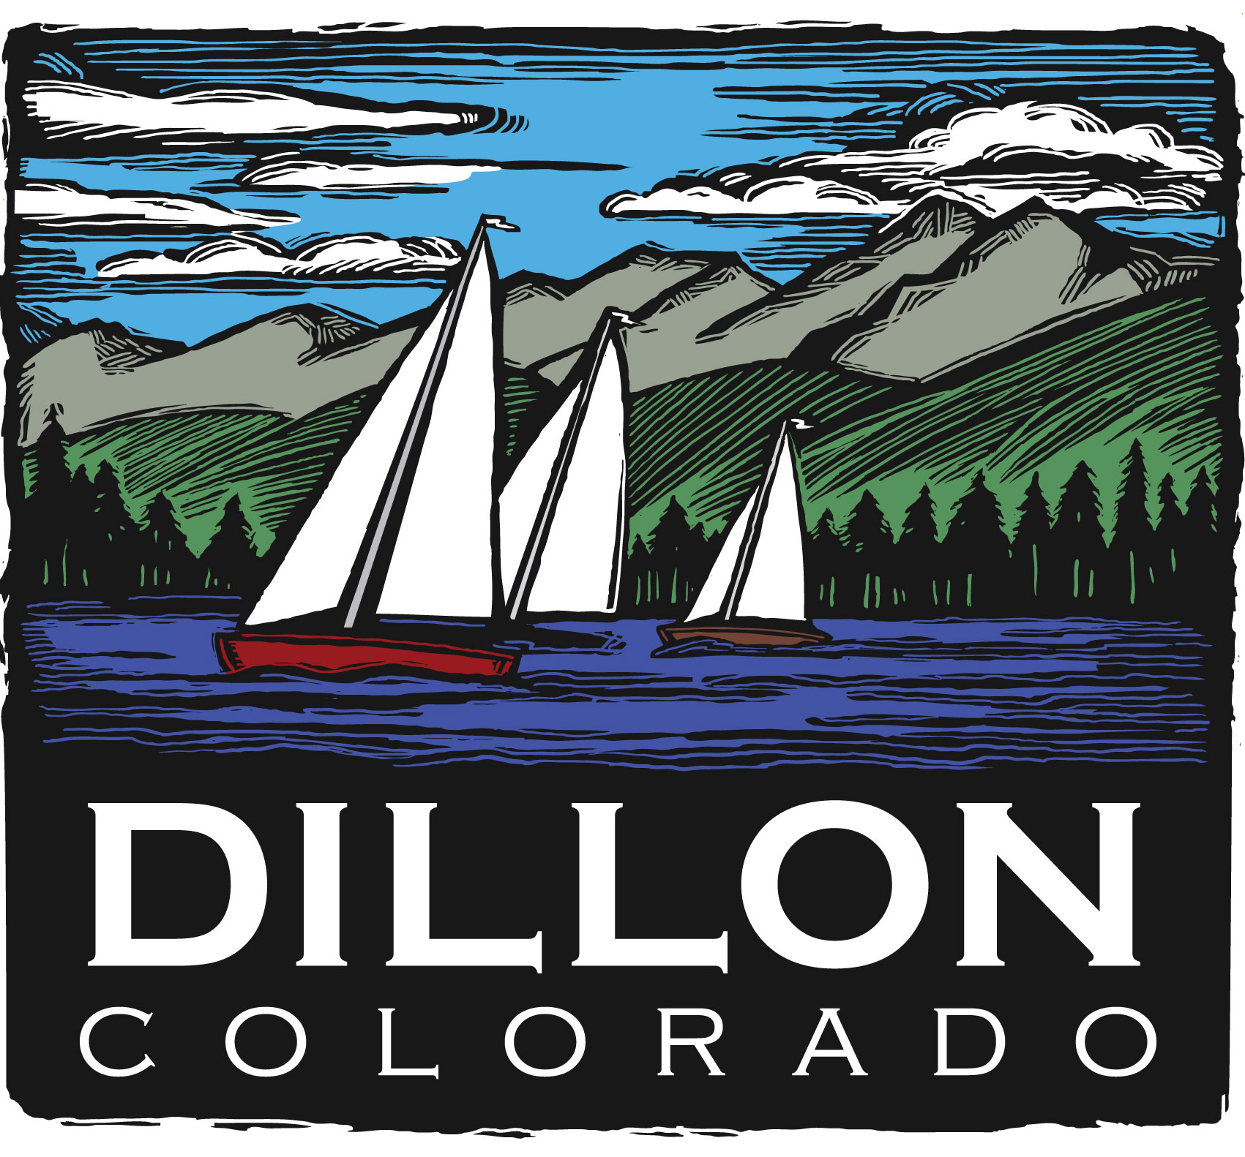
Parks and Recreation Committee
Regular Meeting
July 11, 2011
5:30 PM

Parks and Recreation Mission Statement
The mission of the Parks and Recreation Committee is to protect, improve, and promote our parks and open space for present and future generations. The various park amenities are an integral part of the Town.

Agenda
New Business
Old Business
- BOCCE Update – Rick
Let’s Play BOCCE Public Instruction, Saturday, June 25, 2:00pm, Saturday, July 2, 10:00am, Saturday, July 16, 10:00am, Sunday, July 24, 1:00pm, Saturday, August 6, 10:00am
BOCCE Courts, Dillon Town Park. Come join members of the Summit BOCCE Club and learn you all you need to know to start playing the fun game of BOCCE. BOCCE sets will be available for the instruction or bring your own. Free event.
- Update on Saturday Morning Adventures, Explore Lake Dillon Boat Tours

- Develop Concept for Tree Trust and Memorial Brick Program - All
Determine committee lead, process and goals for this work item. Determine timeline for specific goals and process of communication during research. On hold until fall.

- 2011 Meeting Dates – remaining
July 11
August 1
September 13
October 4
November 1
December 6
October 4
November 1
December 6

- PRAC Reports to Council – Quarterly.
The PRAC will attend work session/council meetings on the following dates;
August 1
November 1
- PRAC Member Terms/Expiration Dates:
Bonnie Hamilton 1/2013
Sue Peterson 1/2013
Rick Giamanco 1/2012
Susan Juergensmeier 1/2012
Barb Richard 1/2012
Jennifer Cassell 1/2013
Kevin Burns 1/2012

Council Member Liaison Jason Smith
P&Z Liaison Yvonne Bryant
Staff Liaison Susan Fairweather
Scott O’Brien

